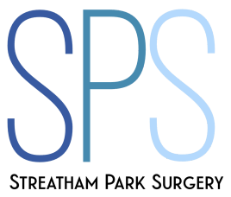

STREATHAM PARK SURGERY

Requests for Medical Reports to Social Services and Housing Departments

If you are intending to apply for a council home for health reasons, YOU DO NOT NEED A DOCTOR’S LETTER.

You need to complete a self-assessment form first and this is usually all that is necessary.
This form is available from the Council (Local Authority).
If the Council needs to know any further information it may then wish to see confidential information from your medical record or your full medical record.

The Local Medical Committee, which represents all NHS general practitioners in the area, has made it clear to the relevant local authorities that GPs will only supply confidential medical information directly to the Local Authority’s Medical Officer when asked to do so by the Officer, provided that the patient (or the patient's legal representative) has given written consent.

The Council should therefore contact you asking you or your legal representative to complete a consent form. Once this has been received they will then write directly to your GP enclosing the written consent and asking your GP to supply confidential medical information which may be all or part of the medical record.

There is therefore no need for you to provide the medical report or to ask your GP to provide it.

If you are experiencing difficulties because of your refusal to supply a report, do not hesitate to show this letter to the Local Authority Department or Housing Association.

